

**Computer & Electronic Engineering**

**Final Year Project "Music Host Interface"**

**Sprint 1: Week 2 Log**

**Thomas Flynn**

**Project Supervisor: Brian O'Shea**

**25/10/15**

**Update:**

This week I received feedback from my Supervisor on how to adjust the scope of my project.

I was advised to remove some of the features I suggested in the project proposal.

I have removed both the Arduino and the FPGA DSP hardware features from Trello Project management system.

**Board adjustments**

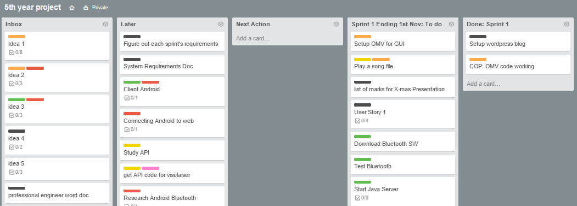

**Updated labels with features removed:**

